# ABC’s Inventory Management System

## Project Plan

## Introduction

ABC is a retail company selling men’s clothing in New South Wales. The company has been growing rapidly, hence requires their warehouse system to be upgraded. The purpose of this project is to provide a digitized inventory management system for ABC. The aim of this document is to provide an introduction to all the team members and define their roles throughout this project. The document also aims to provide details of the technical work packages to be assigned to each team members. This document will also be introducing the management and technical practices and measurements that will be used in the project. Moreover, the document will be introducing the software deployment and update strategy into the production environment. Finally, the document will describe all the milestones of the project and the objectives of each milestone.

## Project Organization

The team assigned for this project is known as ‘Fellowship of the’. The following is a brief introduction of each team members and their roles in the project:

|  |  |
| --- | --- |
| Team Member | Role |
| Shirish Maharjan (the wiz kid) | * Project Manager * Business Analyst * Subject Matter Expert |
| Hieu Hanh Tran (the tech guru) | * Developer * Database Administrator * System Analyst |
| Arik Maharjan (the humble genius) | * Documentation and Marketing * Designer * Tester |

(Note: The role of each team member is subject to change every month so that each team member gets full experience out of the project.)

The following is the detailed description of each role in the project (some of the tasks like programming and documentation needs to be done by each team member. However, the division of these tasks will be done by the project manager.):

|  |  |
| --- | --- |
| Role | Description |
| Project Manager | * Actively Planning * Making Schedules and dividing task * Making sure everyone is working in accordance with the schedule * Conducting Meetings * Making sure the overall work of the team is of high standard * Leading the team * Reviewing final version of products and posting it to the submission document * Documentation * Programming (includes debugging and testing) |
| Developer | * Making sure codes are of appropriate standard * Making sure each team member is on schedule with their coding task * Reviewing code * Make sure there is proper collaboration of codes * Make sure the product is of high standard * Documentation * Programming (includes debugging and testing) |
| Documentation and Marketing | * Making sure all the documentations are of appropriate standard * Preparing reports for each iteration * Preparing reports for meetings with the Sponsor * Making sure team members are on schedule with their documentation tasks * Reviewing documentations if required * Documentation * Programming (includes debugging and testing) |
| Business Analyst | * Assisting with the business case * Planning and monitoring * Eliciting requirements * Translating and simplifying requirements. * Requirements analysis |
| Subject Matter Expert | * Validate the requirements and deliverables that describe the product or service that project will produce * Provide input for design and construction of test cases and scenarios and may also validate executed test results. * Provide input into and create and execute user documentation and training material |
| Database Administrator | * Monitor performance and manage parameters in order to provide fast responses to front-end users. * Map out the conceptual design for a planned database. * Develop, manage and test back-up and recovery plans. * Consider both back-end organization of data and front-end accessibility for end-users. |
| Designer | * Develop intuitive, usable, and engaging interactions and visual designs for system. * Break any design problem done into viable actionable chunks and solve them with clarity and precision. * Collaborate with cross-functional teams throughout the design process. |
| System Analyst | * Defines application problem by conferring with clients; evaluating procedures and processes. * Develops solution by preparing and evaluating alternative workflow solutions. * Ensures operation by training client personnel; providing support. |
| Tester | * Monitoring applications and software systems. * Writing and executing test scripts. * Running manual and automated tests. * Writing bug reports. * Reviewing documentation. * Designing test to mitigate risk. |

Communication is a very important factor for a successful project. Therefore, the following are the communication channels that team members will be using in the project:

1. Face to Face meeting: For detailed discussion about ideas, schedules, tasks and presenting each team member’s work.
2. Telegram: For instant messaging and immediate information sharing.
3. Email: For sending and receiving documents to each other. Emails can also be used to communicate all non-immediate information.
4. Prexip/ CSU Video Conferencing tool: This tool will be used to conduct online meetings and emergency meetings (if necessary). This is a free tool provided by the university which can be used for presentations. It can also be used to help each other out with issues if required.

The details about the communication plan, version control document and the project proposal can be found in the link to the group repository below:

<https://1drv.ms/f/s!AmybkY7r6VWhr0-8rK5CLzhdp2A2>

## Project Practices and Measurements

In this project, software development process and project management will be conducted using the Unified Process (UP) Framework. UP is a use-case driven, architecture centric, risk prioritized, iterative, incremental’ process. Following the UP framework, this project will be iterative and incremental after each iteration. More details about the Unified Process is available on the Project Proposal document. A detailed iteration plan will be made before each iteration starts and each team member will be expected to conduct their tasks in accordance with the iteration plan and integrate their completed tasks. This way team members can keep track of what task was done when and when it was approved. Changes to the project and the iteration plan can also be made if required. After each iteration is completed, a team member will conduct an iteration assessment and write down an iteration burndown report. Gantt charts will be used to plan and schedule the project. This will help team members assess time and resource needs and dependencies of the project. It will also provide a timeline of the entire project.

When all the iterations are completed, a final report will be prepared assessing the entire project to check if any changes need to be made.

## Deployment

This section clarifies the deployment strategy of the software into the production environment. When the alpha version of the software is available, it will be tested by the team members. Following the alpha testing, beta testing will be done by other teams. After this, it will be deployed in the production environment. This is the version of the software which will be analyzed by the sponsor in the production environment. If any more features need to be added or changes needs to be made, a new version of the software will be created and will be tested. This process will continue until the software is accepted and signed by the sponsor.

## Project Milestones and Objectives

The following is the high-level objectives for the iterations and the milestones:

|  |  |  |  |  |  |  |  |  |
| --- | --- | --- | --- | --- | --- | --- | --- | --- |
| **Subject** | | **Phase** | | **Iteration** | | **Dates** | | **Primary objectives** (risks and use case scenarios) |
| ITC303 – Software Development Project 1 | | Inception Phase | | I-1 | | 12/03 – 18/03 | | * Create Iteration Plan * Update project proposal, project plan, team charter and iteration plan * Establish the Project Vision * Start work on the initial Use Case Model * Start work on the analysis class diagram * Establish Proposed Architecture * Establish Risk List |
| 19/03 – 25/03 | | * Start work on the initial Domain Model * Review and update Iteration Plan and version control * Establish meeting minutes for week-4 * Update project vision * Establish master test plan * Create short use case description * Analyze and identify the core use cases * Establish Development Environments * Establish Technical Competency Demonstrator * Update Risk list and version control * Establish Inception Phase Project Status Assessment * Produce iteration assessment and report document |
| I-2 | | 26/03 – 01/04 | | * Create Iteration Plan * Establish meeting minutes for week-5 * Update Project Plan, Iteration Plan and version control * Establish Feedback document for week-5 * Produce Iteration 1 Assessment * Establish Master Test Plan * Establish Inception Phase Project Status Assessment * Update Architecture Notebook, NFR Specification and Use Case Diagram * Finalize Short Use Case Description * Update Project Vision * Finalize Domain Model * Establish the Entity Relationship Diagram * Finalize LCOM documentation * Review and update Iteration Plan, Risk List, Project Plan and Version Control |
| 2/04 - 8/04 | | * Establish LCOM submission ready documents * Analyze and Identify Core use cases * Establish Meeting Minutes for week-6 * Update Iteration Plan, Project Plan, Version Control and Risk List * Deliver Life Cycle Objectives Milestone (LCOM) Assessment Item-2 * Complete Inception Phase Project Assessment and report * Review and update Iteration Plan, Risk List, Project Plan and Version Control * Produce Iteration Assessment |
| Elaboration Phase | | E-1 | | 09/04 – 15/04  (Session Break) | | * Create Iteration Plan * Establish meeting minutes for week-7 * Update Project Plan, Iteration Plan and version control * Establish Feedback document for week-7 * Create Revised Project Vision * Create Revised Requirement Model * Create Final Architecture * Create Revised Risk List * Create Master Test Plan * Create Executable Architecture * Create the Evidence of Testing (User Acceptance Tests, Unit and Integration Tests) * Address and Mitigate the Highest Priority Risky Architectural Element * Review and update Iteration Plan, Version Control and Risk List |
| 16/04 – 22/04 (Session Break) | | * Implement Highest Priority Architectural Element to Support CCRD Use Case * Establish meeting minutes for week-8 * Update Project Plan, Iteration Plan and version control * Establish Feedback document for week-8 * Complete Development Testing for Highest Priority Architectural Element * Create Revised Project Plan * Create Elaboration Phase Project Status Assessment. * Review and update Iteration Plan, Version Control and Risk List * Produce Iteration 4 Assessment |
| E-2 | | 23/4 – 29/04 | | * Create Iteration Plan * Establish meeting minutes for week-9 * Address and Mitigate 2nd Highest Priority Risky Architectural Element * Review and update Iteration Plan, Risk List and Version Control |
| 30/04 – 6/05 | | * Implement 2nd Highest Priority Architectural Element to Support CCRD Use Case * Establish meeting minutes for week-10 * Complete Development Testing for the 2nd Highest Priority Architectural Element * Review and update Iteration Plan, Risk List and Version Control * Produce iteration assessment and report document |
| E-3 | | 7/05 – 13/05 | | * Create Iteration Plan * Establish meeting minutes for week-11 * Address and Mitigate 3rd Highest Priority Risky Architectural Element * Implement 3rd Highest Priority Architectural Element to Support CCRD Use Case * Review and update Iteration Plan, Risk List and Version Control |
| 14/05 – 20/05 | | * Establish meeting minutes for week-12 * Complete Development Testing for the 3rd Highest Priority Architectural Element * Review and update Iteration Plan, Risk List and Version Control * Produce iteration assessment and report document |
| E-4 | | 21/05 – 27/05 | | * Create Iteration Plan * Establish meeting minutes for week-13 * Deploy Executable Architecture in Trial Environment * Implement Highest Priority Use Case * Complete Development and Integration Testing for Highest Priority Use Case * Conduct User Acceptance Tests for Critical Core Use Case * Review and update Iteration Plan, Risk List and Version Control |
| 28/05 – 03/06 | | * Establish meeting minutes for week-14 * Contingency * Review the Project Plan * Review the architecture and design documentations * Review and update Iteration Plan, Risk List and Version Control * Deliver Life Cycle Architecture Milestone (LCAM) * Complete Elaboration Phase Project Assessment and report document |
| Mid-year Semester Break | | | | | | | | |
| Mid-year Semester Break | | | | | | | | |
| ITC309 – Development Project 2 | Construction Phase | | C-1 | | 11/07 – 24/07 | | * Create Iteration Plan * Implement 2nd Highest Priority Use Case(s) * Complete Development and Integration Testing for 2nd Highest Priority Use Case(s) * Complete Internal User Acceptance Testing for 2nd Highest Priority Use Case(s) * Produce Iteration assessment and report document | |
| C-2 | | 25/07 – 7/08 | | * Create Iteration Plan * Implement 3rd Highest Priority Use Case(s) * Complete Development and Integration Testing for 3rd Highest Priority Use Case(s) * Complete Internal User Acceptance Testing for 3rd Highest Priority Use Case(s) * Produce Iteration assessment and report document | |
| C-3 | | 8/0 – 21/08 | | * Create Iteration Plan * Implement 4th Highest Priority Use Case(s) * Complete Development and Integration Testing for 4th Highest Priority Use Case(s) * Complete Internal User Acceptance Testing for 4th Highest Priority Use Case(s) * Produce Iteration assessment and report document | |
| C-4 | | 22/08 – 4/09  (Session Break) | | * Create Iteration Plan * Contingency * Deliver Initial Operation Capability Milestone (IOCM) * Complete Construction Phase Project Assessment and report | |
| Transition Phase | | T-1 | | 5/09 – 18/09 | | * Create Iteration Plan * Deploy Application in Trial Environment * Complete 1st Round External User Acceptance Testing * Resolve Any Identified Issues * Review and update iteration plan and produce iteration report | |
| T-2 | | 19/09 – 2/10 | | * Create Iteration Plan * Complete 2nd Round External User Acceptance Testing * Resolve Any Identified Issues * Review and update iteration plan and produce iteration report | |
| T-3 | | 3/10 – 14/10 | | * Create Iteration Plan * Contingency * Deliver Product Release Milestone (PRM) * Complete Final Project Assessment * Produce Final Report and Project Review | |

## Gantt Chart

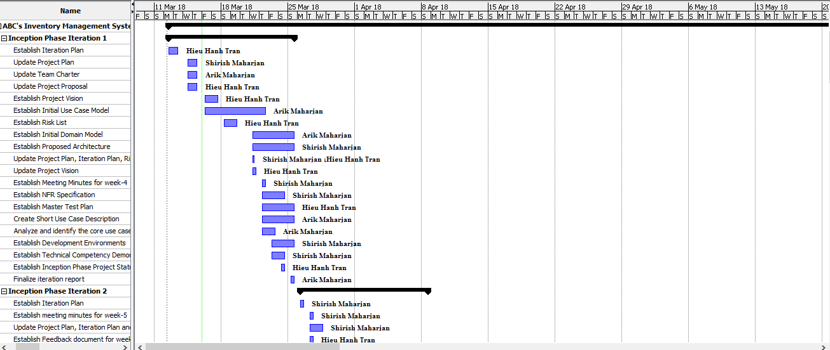

The full Gantt Chart is included in the Project Libre File namely ABC's Inventory Management System Gantt Chart 2.1.